Strengthening exercises for tennis elbow
Wrist curls
- Place your forearm on a table with your hand hanging over the edge of the table, palm up.  - Place a 1- to 2-pound weight in your hand. This may be a dumbbell, a can of food, or a filled water bottle.  - Slowly raise and lower the weight while keeping your forearm on the table and palm facing up.  - Repeat this motion 20 times.  - Switch arms.  - Repeat with your hand facing down toward the floor. Switch arms.  - Over a period of weeks, gradually increase the number of sets of 20 repetitions you do in one session. | 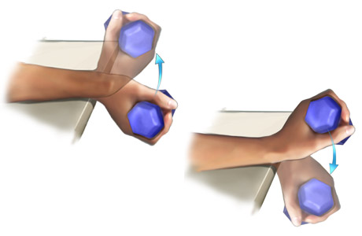
Biceps curls
- Sit leaning forward with your legs slightly spread and your left hand on your left thigh.  - Place your right elbow on your right thigh and hold the weight with your forearm horizontal.  - Slowly curl the weight up and toward your chest.  - Repeat this motion 20 times.  - Switch arms.  - Over a period of weeks, gradually increase the number of sets of 20 repetitions you do in one session. | 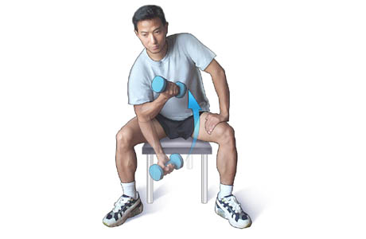
Illustrations copyright 2002, 2003 Nucleus Communications, Inc. All rights reserved. http://www.nucleusinc.com
Primary Medical Reviewer | William M. Green, MD  - Emergency Medicine
Primary Medical Reviewer | Steven L. Schneider, MD  - Family Practice
Specialist Medical Reviewer | David Pichora, MD, FRCSC  - Orthopedic Surgery
Last Updated | March 5, 2003
© 1995-2004, Healthwise, Incorporated, P.O. Box 1989, Boise, ID 83701. All Rights Reserved.
This information is not intended to replace the advice of a doctor.

