Stretching exercises for tennis elbow
Prayer stretch
- Start with your palms together in front of your chest just below your chin.  - Slowly lower your hands toward your waistline, keeping your hands close to your stomach and your palms together until you feel a mild to moderate stretch under your forearms.  - Hold 20 seconds. Repeat 4 times. | 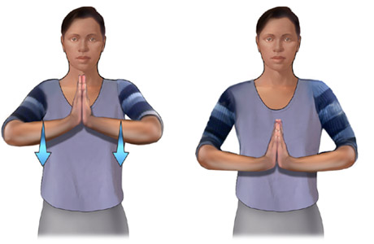
Reverse prayer stretch
- Start with the backs of your hands together in front of you at your waistline, with your forearms parallel to the floor.  - Slowly bring your wrists up toward your face by bending your elbows until you feel a mild to moderate stretch in your forearms. Keep the backs of your hands together and your hands close to your body.  - Hold 20 seconds. Repeat 4 times. | 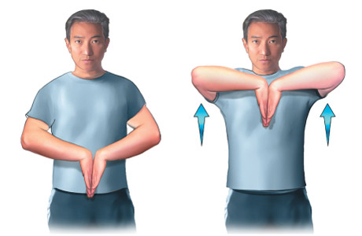
Illustrations copyright 2003 Nucleus Communications, Inc. All rights reserved. http://www.nucleusinc.com

Wrist flexor stretch  - Extend your arm in front of you with your palm up.  - Bend your wrist, pointing your hand toward the floor.  - With your other hand, gently bend your wrist further until you feel a mild to moderate stretch in your forearm.  - Hold for 20 seconds. Repeat 4 times.  Wrist extensor stretch  - Repeat steps 1 to 4 of the stretch above but begin with your extended hand palm down. | 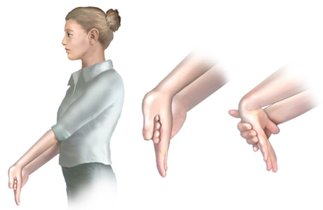
Thumb stretch
- Place your forearm on a table with your thumb pointing upward and your hand hanging over the edge of the table.  - Lower your thumb toward the base of your little finger and close your hand into a fist.  - Slowly lower your hand so your little finger moves toward the floor (as if you're shaking hands).  - Hold for 20 seconds. Repeat 4 times. | 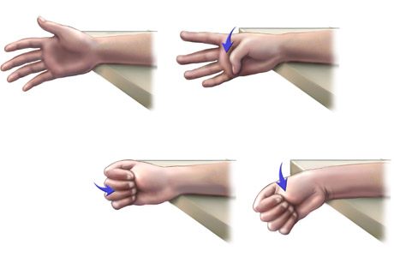
Primary Medical Reviewer | William M. Green, MD  - Emergency Medicine
Primary Medical Reviewer | Steven L. Schneider, MD  - Family Practice
Specialist Medical Reviewer | David Pichora, MD, FRCSC  - Orthopedic Surgery
Last Updated | March 5, 2003
© 1995-2004, Healthwise, Incorporated, P.O. Box 1989, Boise, ID 83701. All Rights Reserved.
This information is not intended to replace the advice of a doctor.

