Warm-up exercises for tennis elbow
Thumb and finger opposition
- Begin by placing your hand on a table in front of you, with your palm up.  - Touch your thumb and little finger, then your thumb and ring finger, then thumb and middle finger, and finally your thumb and index finger.  - Repeat this cycle 20 times. | 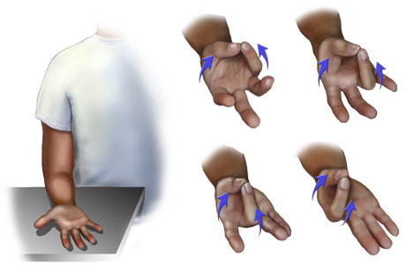
Wrist circles
- Place your forearm on your thigh, palm up, with your hand in a very light fist.  - Make slow circles with your hand.  - Repeat 20 times. | 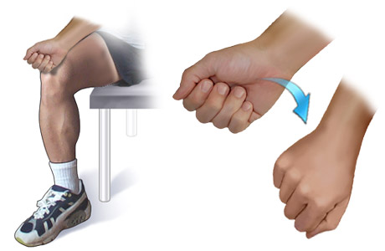

Hand flips
- Place your hand palm down on your thigh.  - Flip your hand over so the back of your hand rests on your thigh and your palm is up.  - Repeat 20 times. | 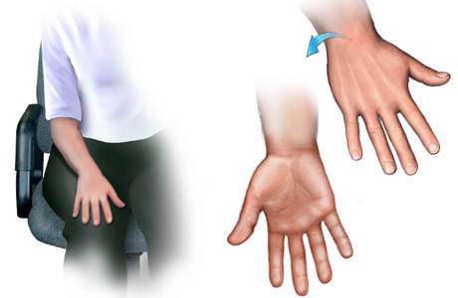
Illustrations copyright 2003 Nucleus Communications, Inc. All rights reserved. http://www.nucleusinc.com
Primary Medical Reviewer | William M. Green, MD  - Emergency Medicine
Primary Medical Reviewer | Steven L. Schneider, MD  - Family Practice
Specialist Medical Reviewer | David Pichora, MD, FRCSC  - Orthopedic Surgery
Last Updated | March 5, 2003
© 1995-2004, Healthwise, Incorporated, P.O. Box 1989, Boise, ID 83701. All Rights Reserved.
This information is not intended to replace the advice of a doctor.

